**Advanced DevOps Experiment-1**

**Aim:** Using AWS CodePipeline, deploy Sample Application on EC2 instance using AWS CodeDeploy.

**Theory:-**

Amazon Elastic Compute Cloud (Amazon EC2) offers flexible, on-demand computing capacity in the Amazon Web Services (AWS) Cloud, enabling faster development and deployment of applications without the need for upfront hardware investments. EC2 allows you to launch and manage virtual servers based on your workload needs. You can adjust security settings, configure networking, and manage storage efficiently.

EC2’s scalable nature lets you easily increase capacity (scale up) to handle compute-intensive tasks such as data analysis, seasonal traffic spikes, or resource-heavy applications. Conversely, when demand decreases, you can reduce capacity (scale down), ensuring cost-effective resource management.

Each EC2 instance is a virtual server, and the instance type you select determines the combination of compute, memory, network, and storage resources available. This flexibility ensures you can tailor your environment to meet specific performance and cost requirements. For further details, refer to the Amazon EC2 Instance Types Guide.

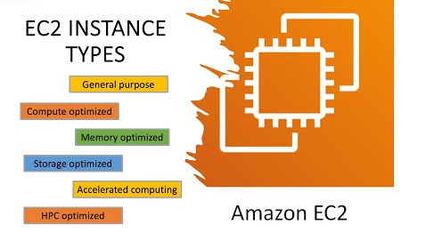

## 

## 

**Key Features of Amazon EC2**

**Amazon EC2 offers a range of powerful features to enhance your cloud computing experience:**

**Instances:** Virtual servers that you can configure and launch to meet your application needs.

**Amazon Machine Images(AMIs):** Preconfigured templates containing the necessary components for your server, such as the operating system and additional software.

**Instance Types:** A variety of configurations offering different combinations of CPU, memory, storage, networking capacity, and graphics hardware, allowing you to choose the best fit for your workloads.

**Amazon EBS Volumes:** Persistent storage solutions using Amazon Elastic Block Store (Amazon EBS) that provide durable storage for your data.

**Instance Store Volumes:** Temporary storage that offers high-performance local storage for your instance, deleted automatically when the instance is stopped, hibernated, or terminated.

**Key Pairs:** Secure login credentials for your instances, with AWS storing the public key and you keeping the private key in a secure location.

**Security Groups:** Virtual firewalls that enable you to control inbound and outbound traffic by specifying allowed protocols, ports, and IP ranges.

**PCI DSS Compliance**: Amazon EC2 supports the secure processing, storage, and transmission of credit card data, adhering to the Payment Card Industry Data Security Standard (PCI DSS). For further details and to request the AWS PCI Compliance Package, refer to the PCI DSS Level 1 guidelines.

These features provide a robust and secure foundation for deploying, managing, and scaling applications in the cloud Implementation:-

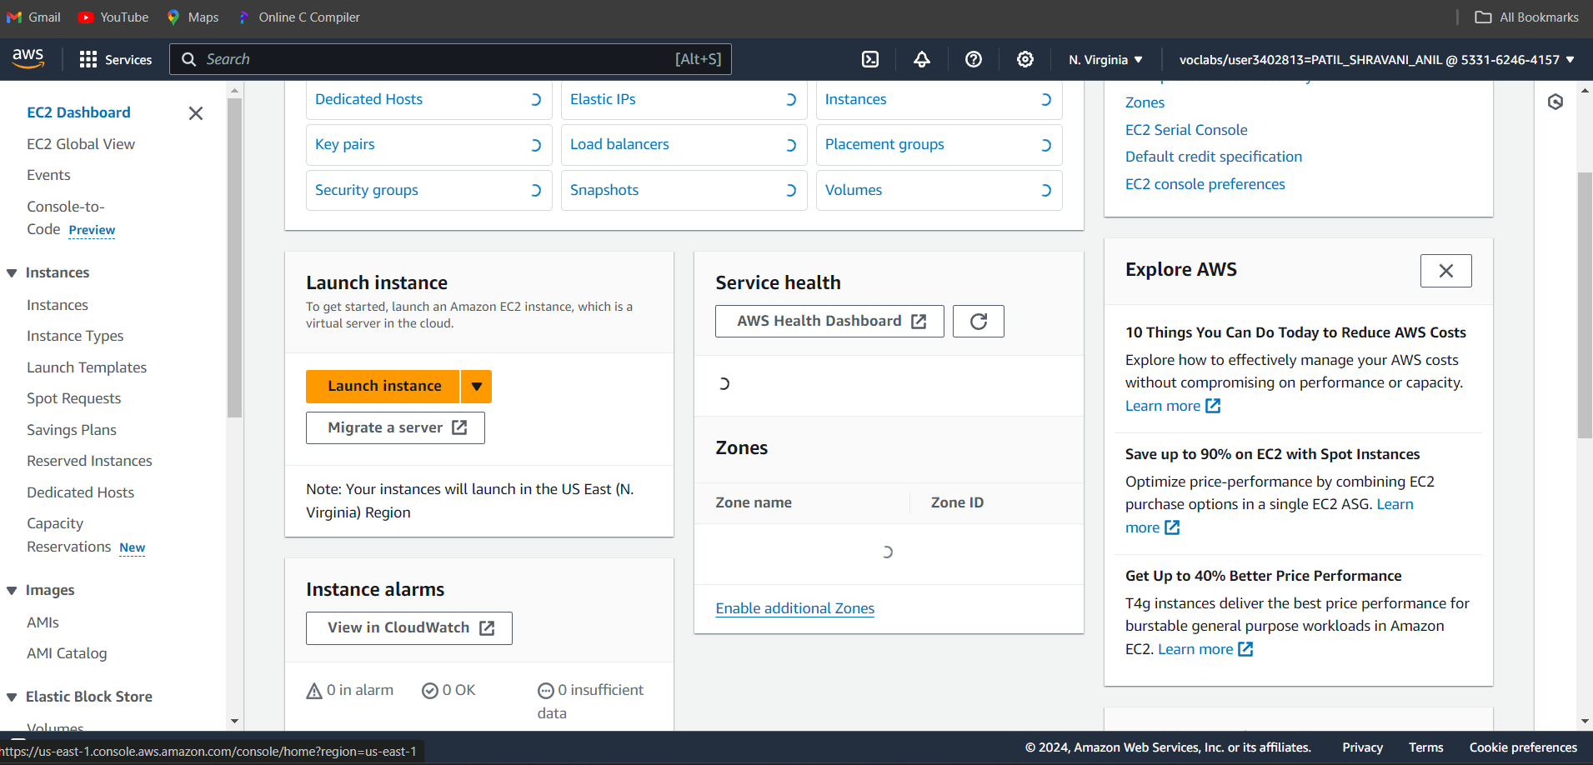

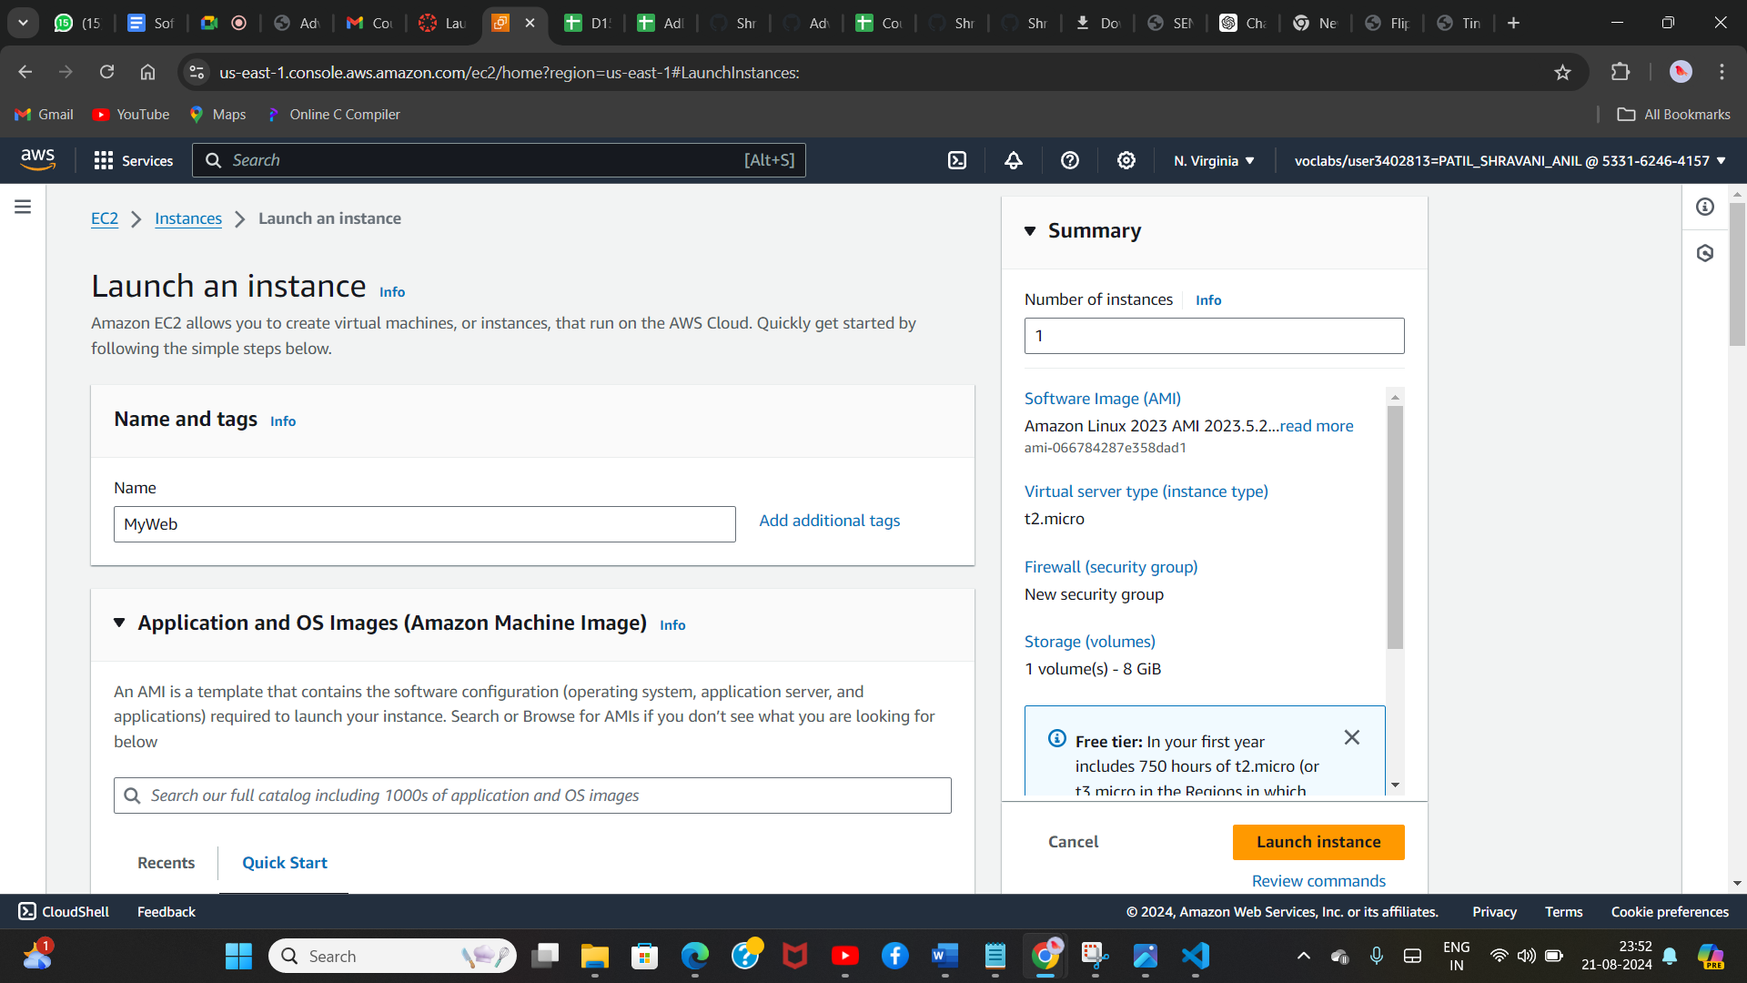

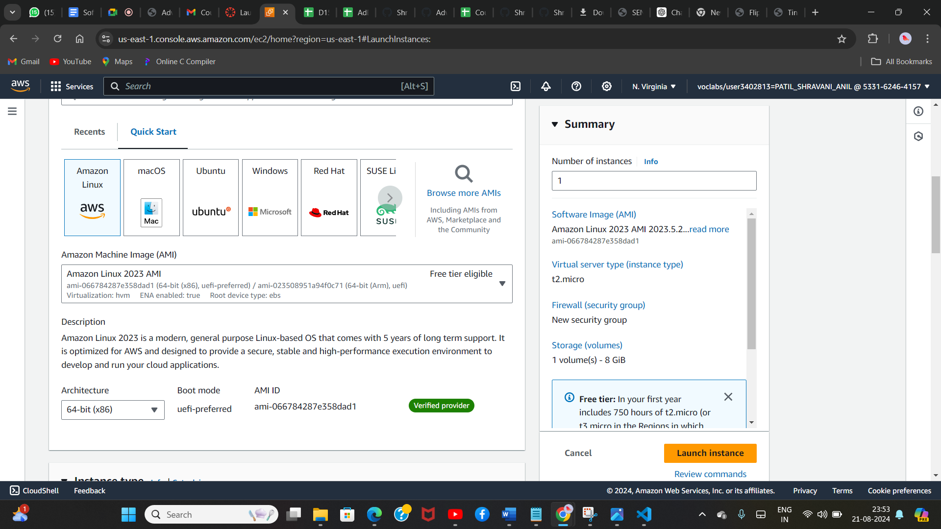

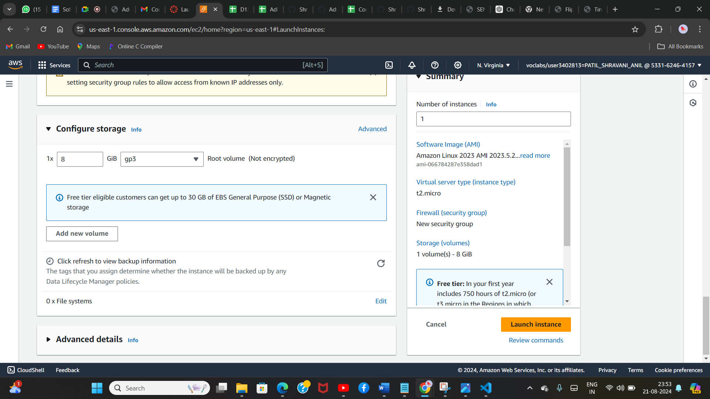

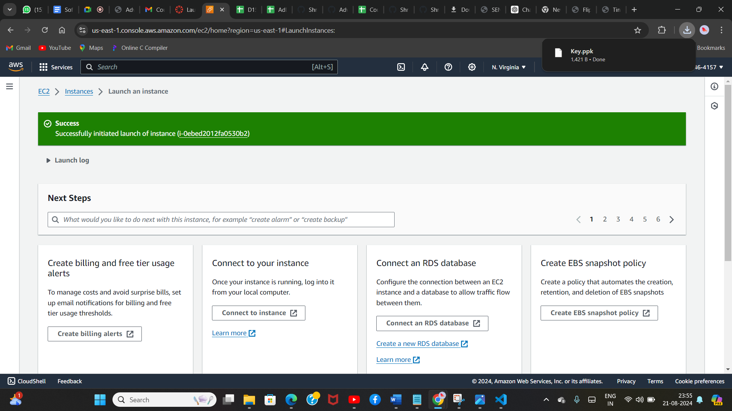

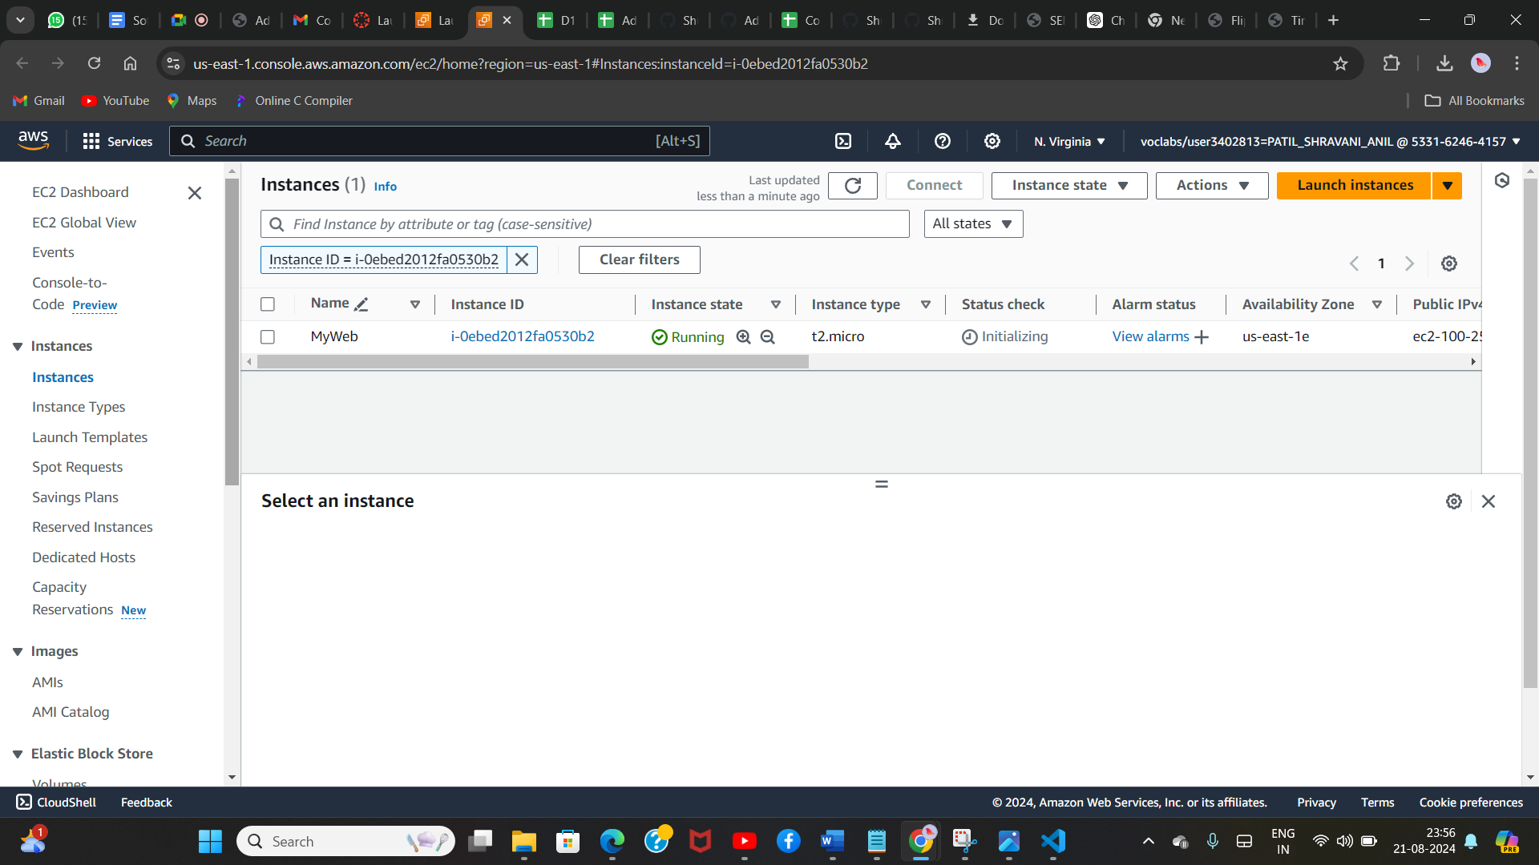

1. **Hosting a static website using EC2 instance**

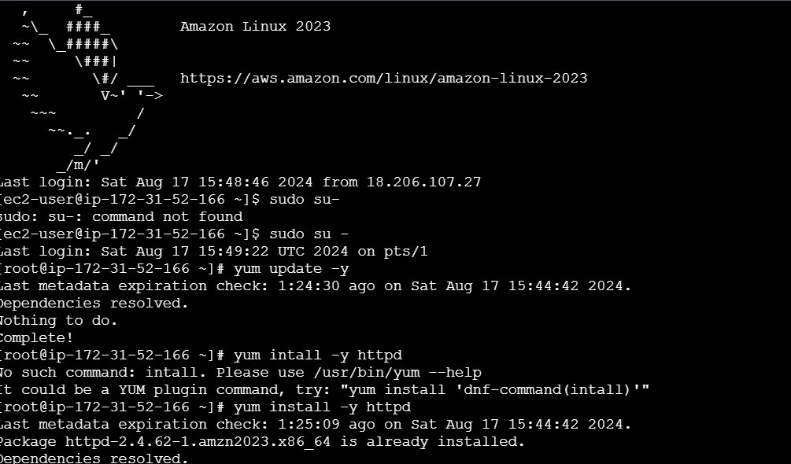

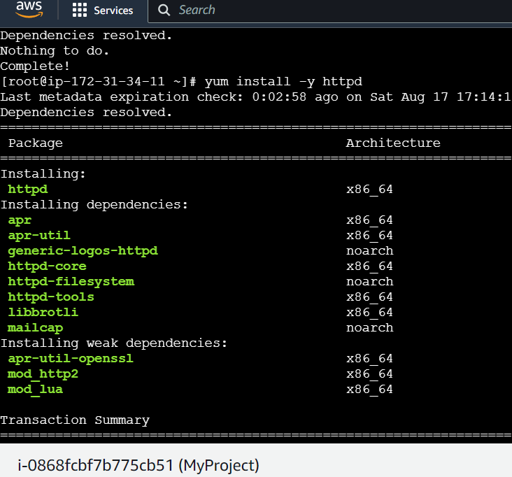

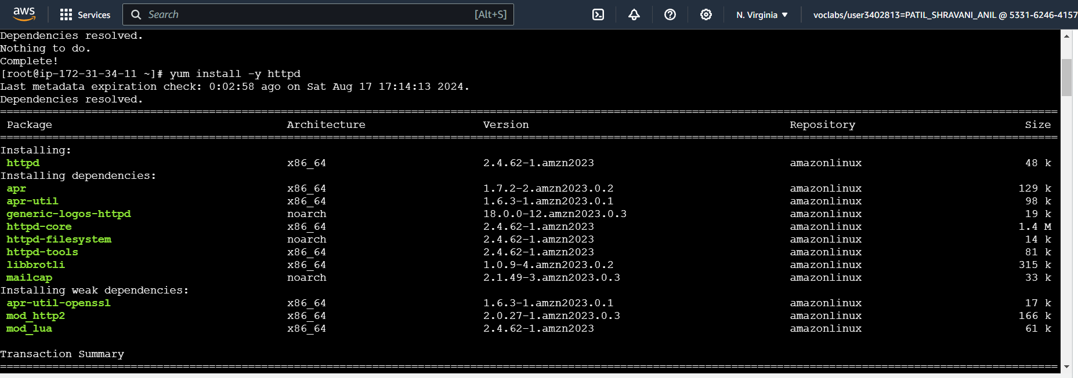

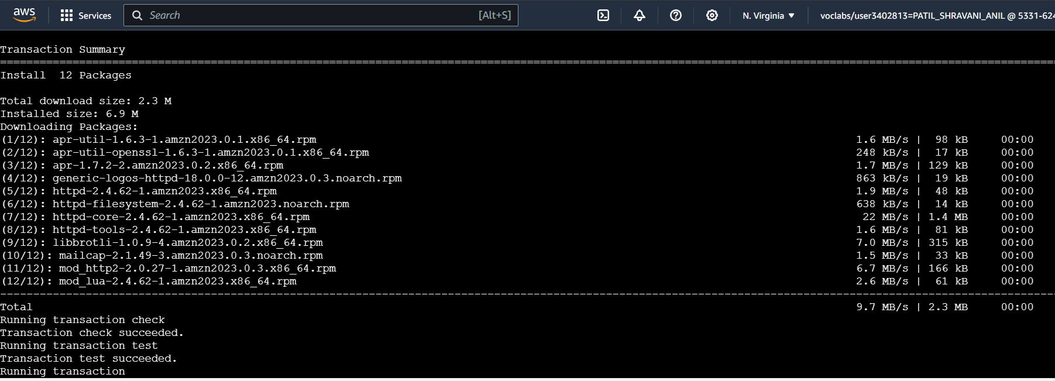

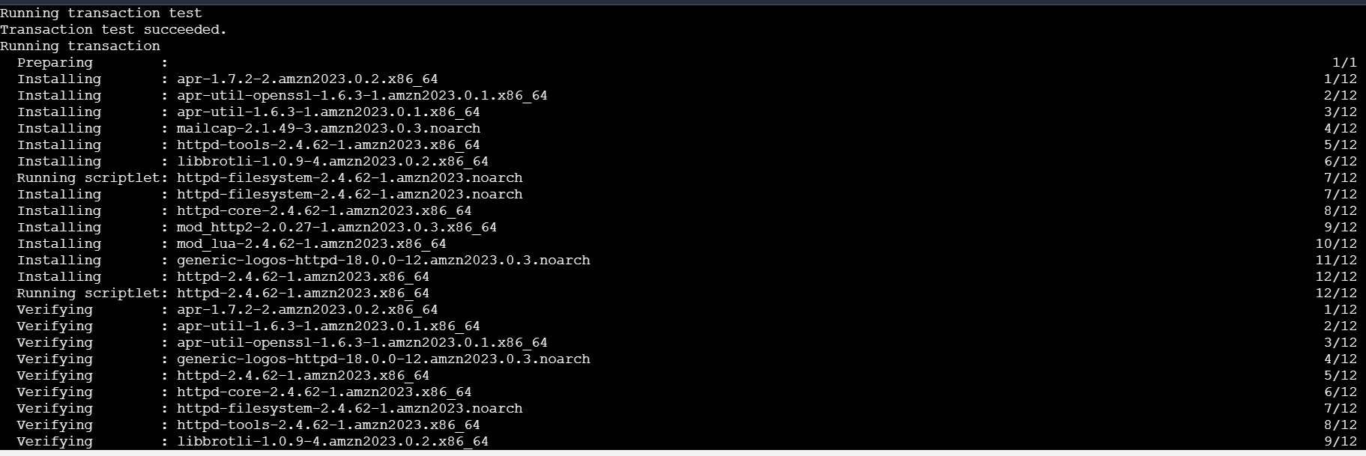

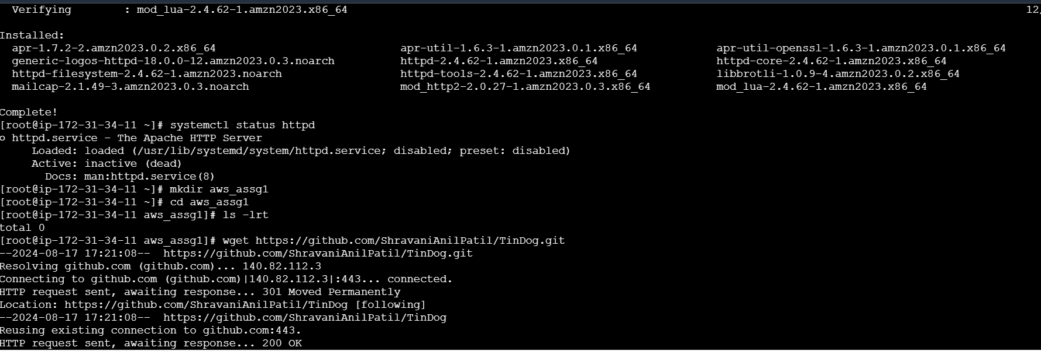

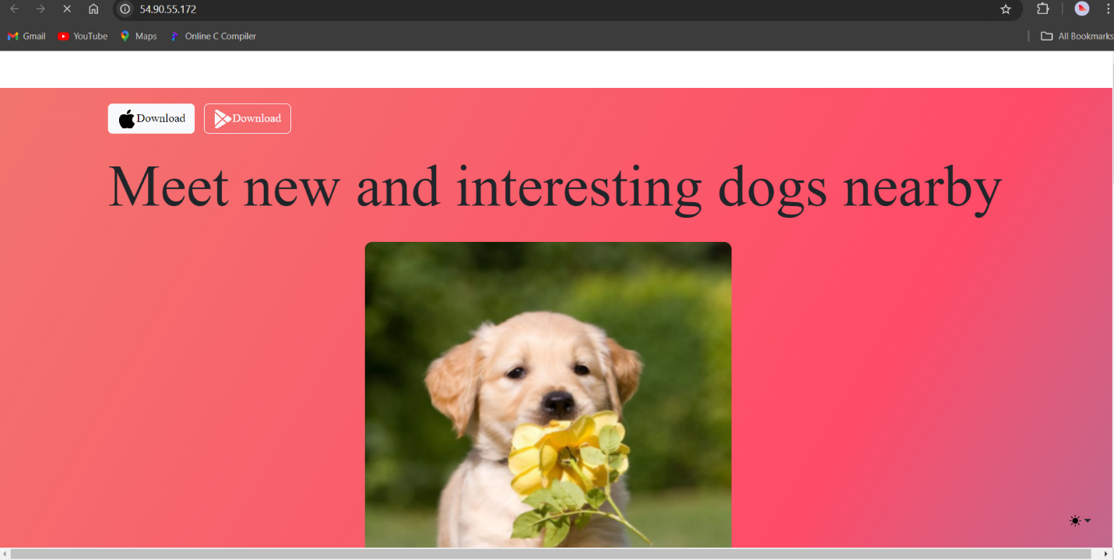

1. **Hosting using S3 bucket**

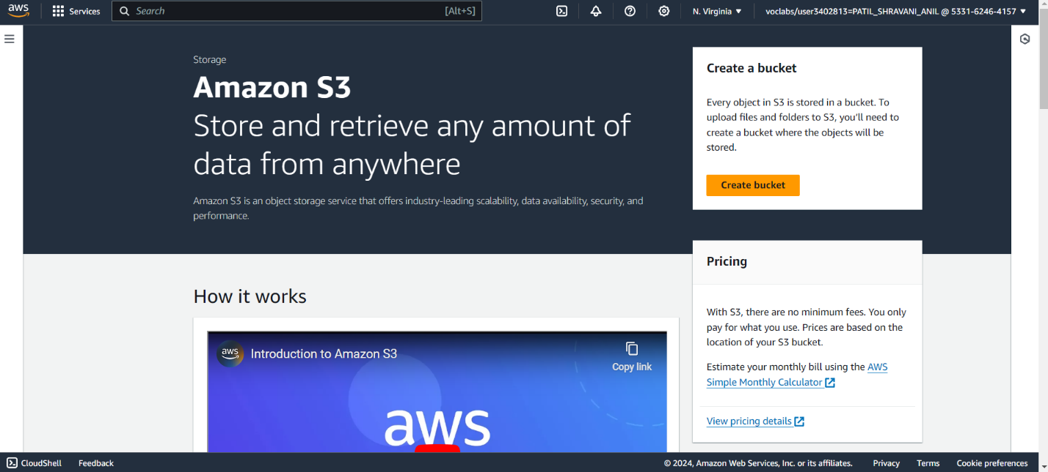

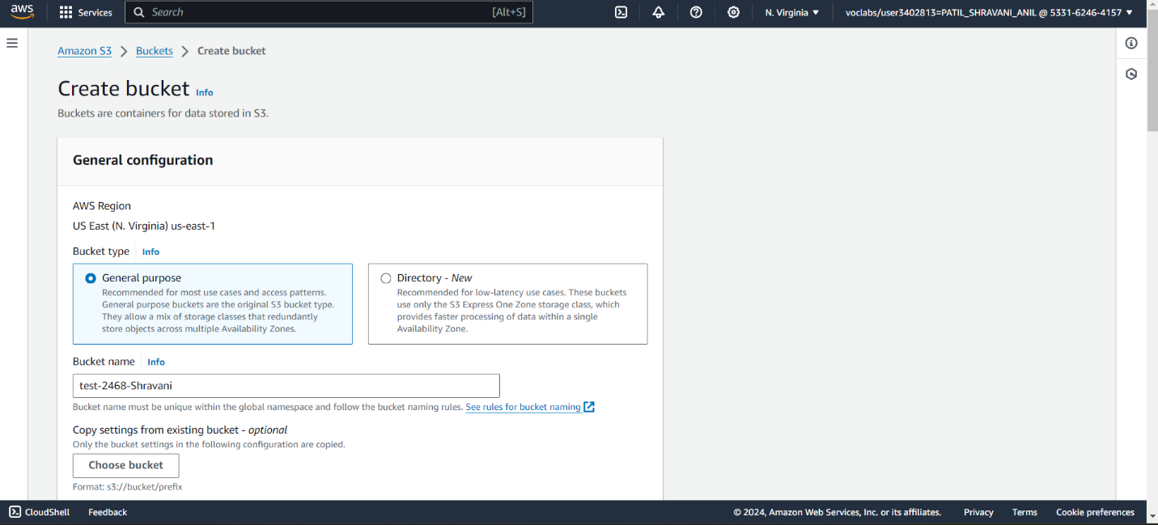

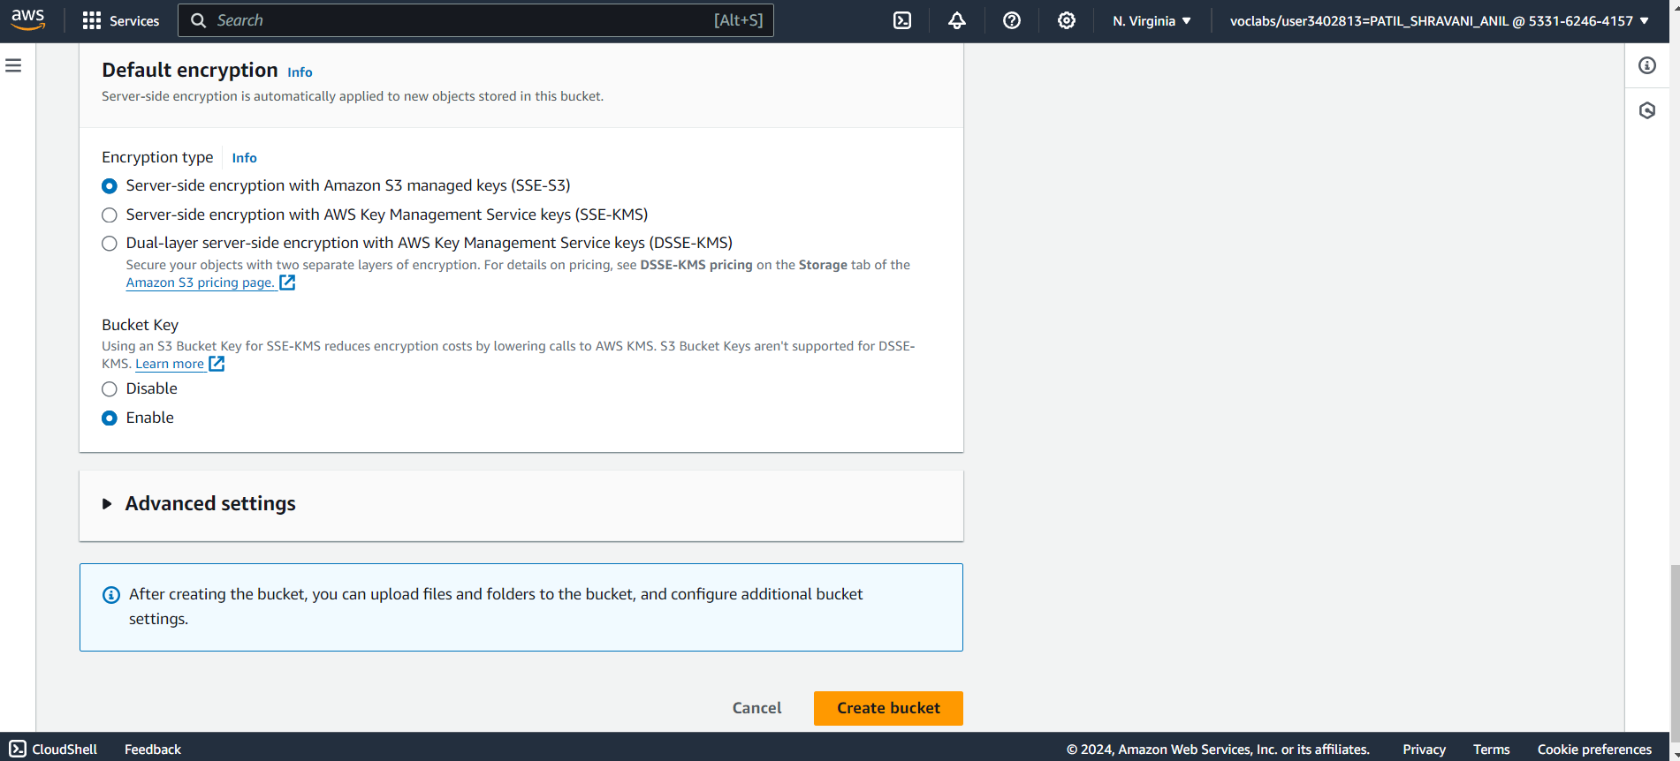

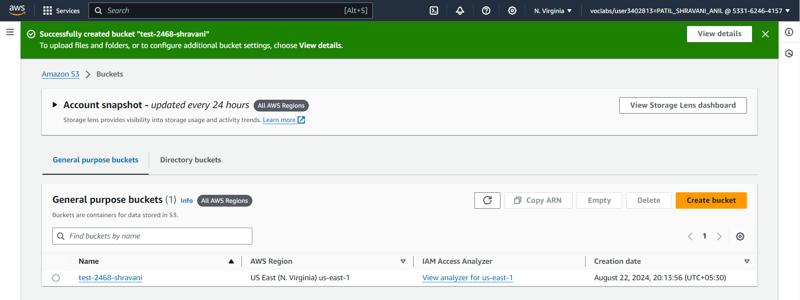

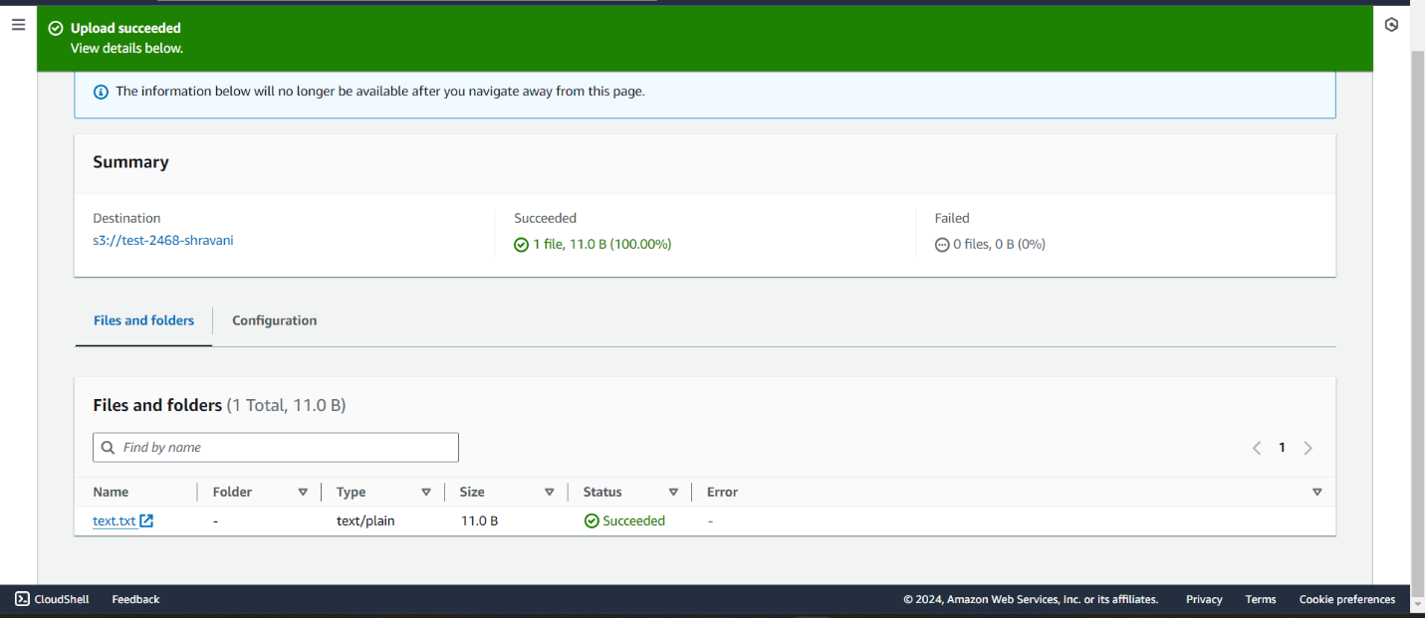

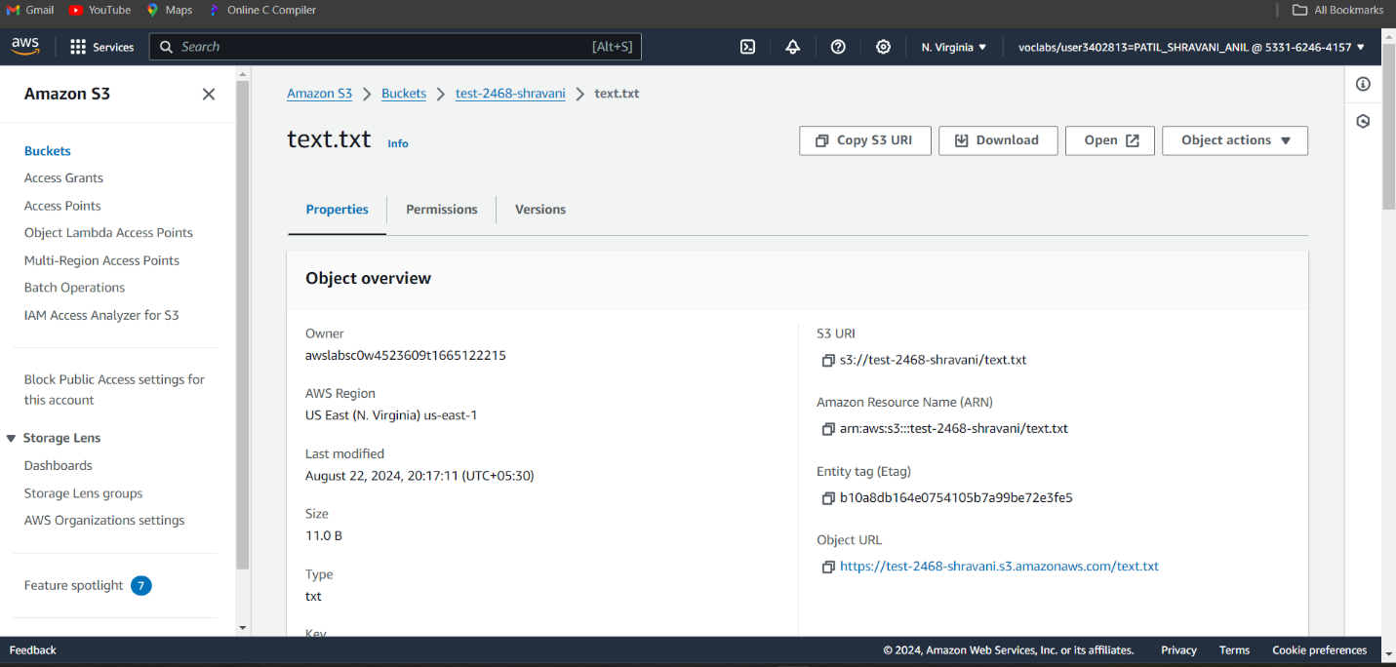

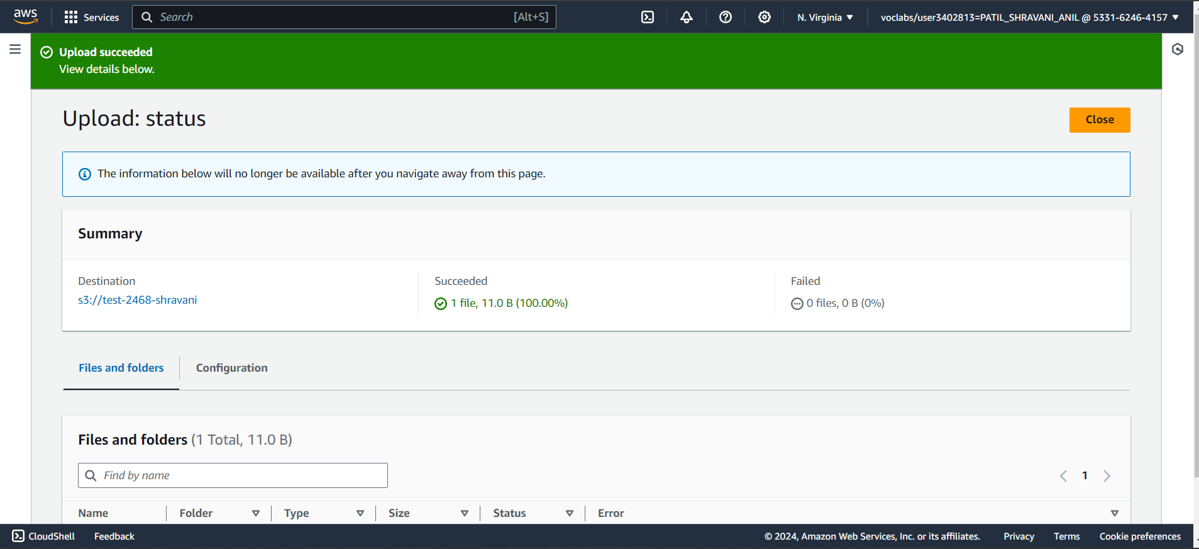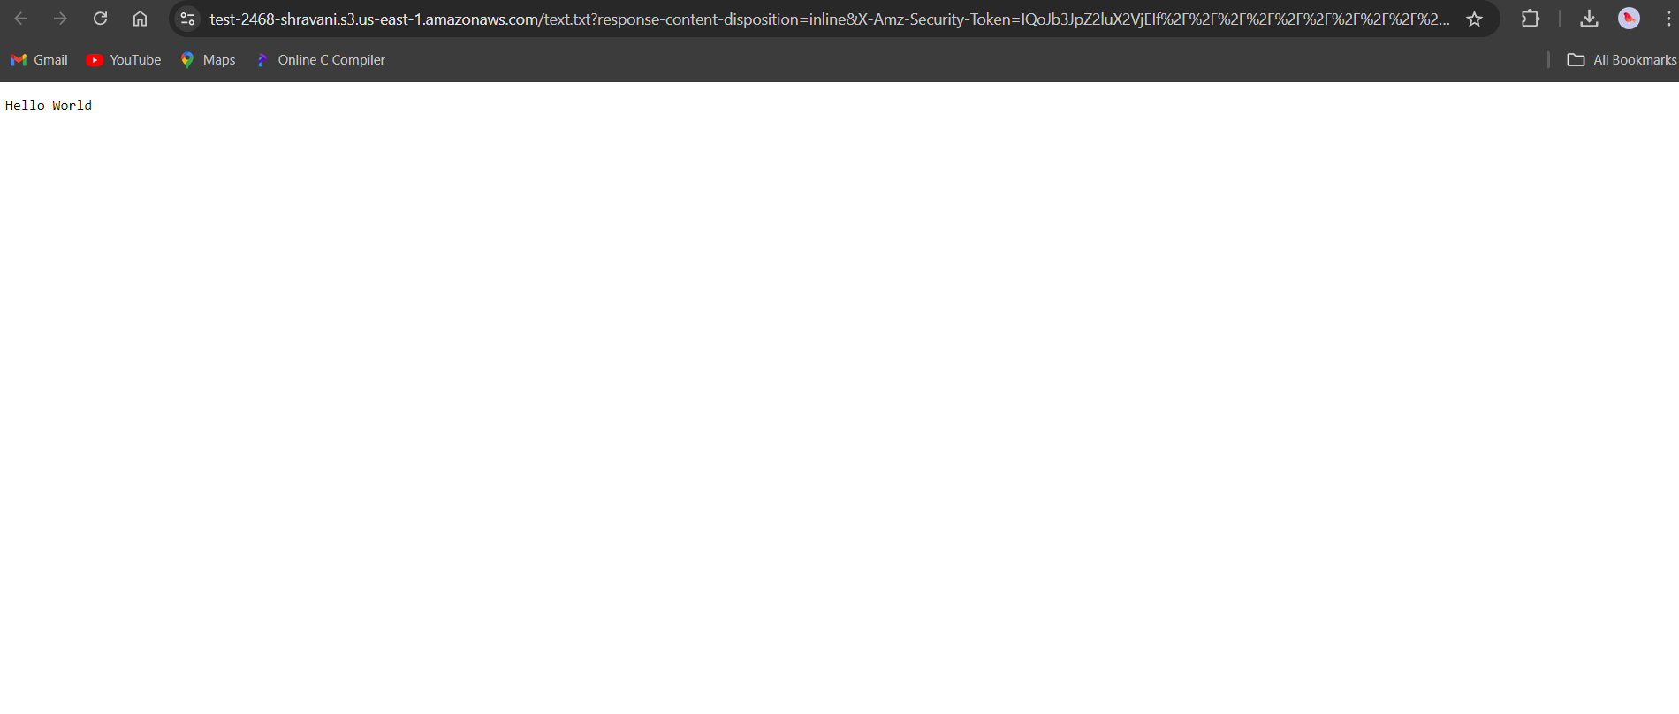

1. **Hosting using Cloud 9**

